ve

* **Central Equipment Identity Register System Admine Portal**

**Customer Care User Manual v 2.1**

Document Change History

|  |  |  |  |
| --- | --- | --- | --- |
| Version | Change Type | Description | Date |
| Draft |  | Submitted for internal review | February 2020 |
| Version 2.0 |  | Multiple System Admin, Configurable Notifications, Filter and sorting, Field Validations, History of the request, Address management | June 2021 |

Contents

1 Overview 1

1.1 Scope 1

1.2 Acronyms & Abbreviations 1

1.3 Conventions 1

2 Customer Care Agent Operations 2

2.1 Application Overview 2

2.2 Logging into the Application 2

2.3 Application User Interface 3

2.4 Grievance 5

2.5 Filter Grievance 10

2.1 Sorting Grievances 11

2.2 Exporting Grievances 11

2.3 Search 12

Figures

Figure 1: Login 2

Figure 2: Search Page 3

Figure 3: Change Password 4

Figure 4: Change Password 4

Figure 5: Grievance – View All 5

Figure 6: Grievance – Create Grievance User ID Enter Option 6

Figure 7a: Grievance – Create Grievance for internal users 7

Figure 7b: Grievance – Create Grievance for external users 8

Figure 8: Grievance – Filter Option 10

Figure 9: Sort Grievances 11

Figure 10: Grievance Management 11

Figure 11: Open or Save Exported Grievance File 12

Figure 12: Exported Grievances 12

Figure 13: Search – IMEI 12

Figure 14: Search – Search IMEI 13

# Overview

## Scope

The objective of this manual is to help Customer Care Agent to search IMEI and raise grievance using the CEIR (Central Equipment Identity Register) application.

## Acronyms & Abbreviations

| **Acronym** | **Full Form** |
| --- | --- |
| CEIR | Central Equipment Identity Register |
| IMEI | International Mobile Equipment Identity |
| PDA | Personal Digital Assistant |
| TAC | Type Allocation Code |
| TRC | Telecommunication Regulator of Cambodia |
| CCA | Customer Care Agent |

## Conventions

| **Information** | **Convention** |
| --- | --- |
| UI elements  (such as names of windows, buttons, and fields) | Bold |
| References  (such as names of files, sections, paths, and  parameters) | *Italics* |
| **\*** | Indicates a mandatory field or column |

# Customer Care Agent Operations

## Application Overview

The CEIR (Central Equipment Identity Register) Customer Care Agent Portal is used in various work-flow in the CEIR application.

Customer Care Agent perform the following tasks:

* Grievance Management
* Search IMEI

## Logging into the Application

Before login, the Customer Care Agent must register in the application.

To register:

As part of configuration, the System Admin would provide the login details to the Customer Care Agent. It is advised to change the password once System Admin creates the account.

To login:

1. Open the browser and enter the CEIR Customer Care Agent Portal URL in the address bar. The login screen appears.

Figure 1: Login

On the top right corner of the login screen is the **Language** option. The application supports two languages: **English** and **Khmer**. On selecting a given language, all the field and column labels in the application appear in the selected language. All user inputs are, however, in English.

1. Next, enter the assigned login username and password.

Username is the registration ID that is sent on mail to the System Admin after successful registration in the system.

1. Enter the captcha.
2. Click **LOGIN**.

If the login and password are incorrect or the captcha is not correct, an error message appears, and you are prompted to re-enter the login details.

On entering correct information, the application Search page appears.

If the Customer Care Agent forgets the assigned password, then the same need to request from the System admin. The **Forgot Password** link work for external user who register themselves from the DMC portal

## Application User Interface

On logging into the application successfully, the CEIR Customer Care Agent Portal Search page appears.

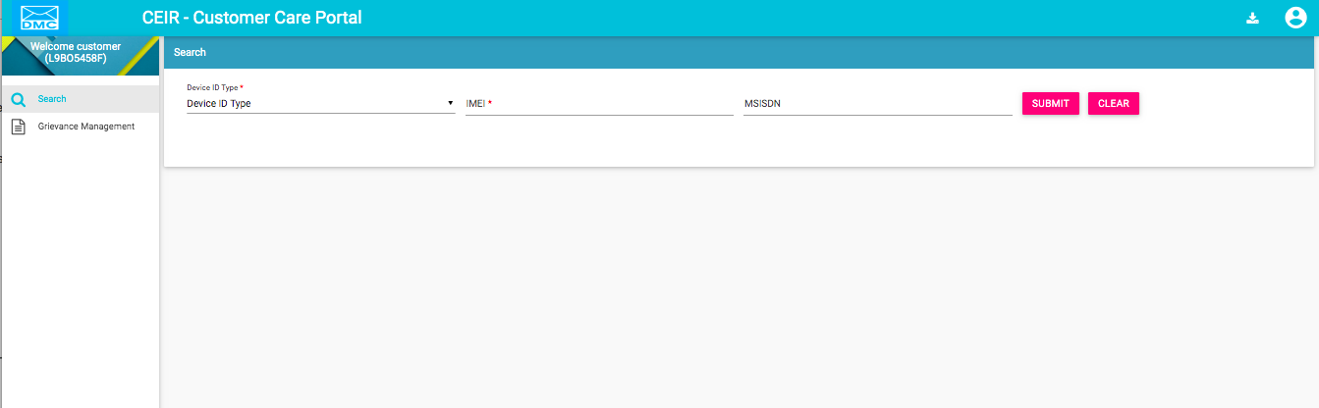

Figure 2: Search Page

The Home page has all the feature menus on the left panel.

The top right corner of the screen displays the following menu options:

* **Download**: Click to download this user manual.
* A close up of a logo

  Description automatically generated(**User profile**): Click on it to see the following menu:

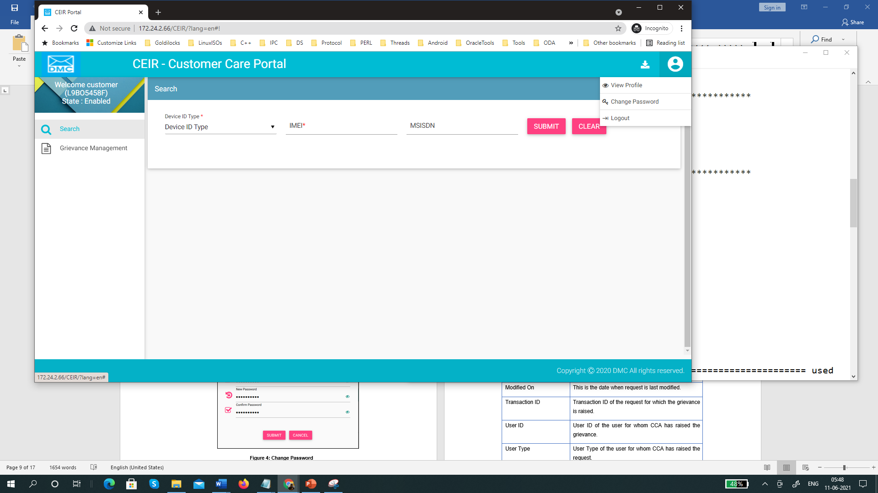

*  (**View profile**): Click on it to view user profile.

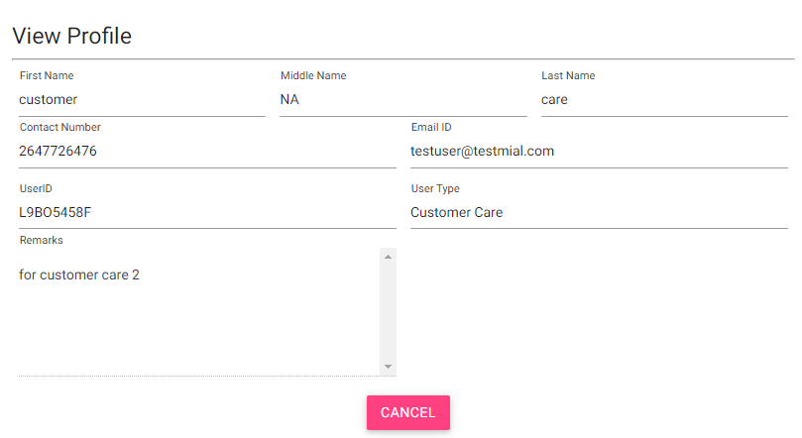

Figure 3: Change Password

* (**Change Password**): Click on it to change the login password.



Figure 4: Change Password

1. **Old Password**: Enter the existing password. Click  to see the password characters being entered. Click on it again to hide the password characters. This works like a toggle key.
2. **New Password**: Enter a new password.
3. **Confirm Password**: Re-enter the new password to confirm the password.
4. Click **SUBMIT**.

## Grievance

Customer Care Agents can raise grievance request on behalf of the user.

To raise the request:

1. Select **Grievance** in the left panel

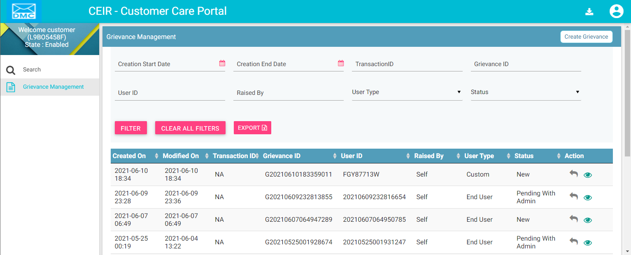

Figure 5: Grievance – View All

The following columns are seen in the Grievance Page

| **Column** | **Description** |
| --- | --- |
| Created On | This is the date when request is created |
| Modified On | This is the date when request is last modified. |
| Transaction ID | Transaction ID of the request for which the grievance is raised. |
| User ID | User ID of the user for whom CCA has raised the grievance. |
| User Type | User Type of the user for whom CCA has raised the request. |
| Grievance ID | Grievance ID of the grievance |
| Raised By | This parameter denotes who has raised the grievance. The Value of this parameter would be Customer Care |
| Status | The grievance goes through different status modes.   * New: When a grievance is raised. * Pending with CEIR Authority: When a response is awaited from the CEIR Admin. * Pending with User: When a response is awaited from the importer.   Closed: When the CEIR Admin closes the grievance. |
| Action | This displays different actions that can be performed on a grievance.   * Reply: This is disabled for customer care agent. * View A close up of a logo    Description automatically generated: This is used to view the grievance response history. The CEIR admin can see all the responses exchanged for any grievance |

Click on “Create Grievance” to create a grievance for a user.

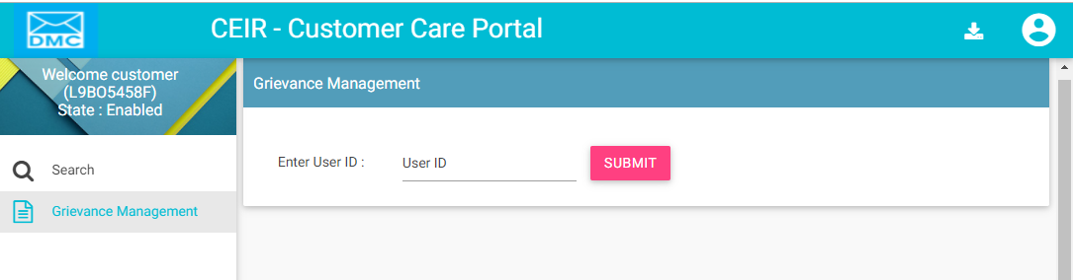

Figure 6: Grievance – Create Grievance User ID Enter Option

This feature works for both internal users and external users. For internal users, enter User ID of the user for whom the grievance has to be raised. For external users, enter name of the user.

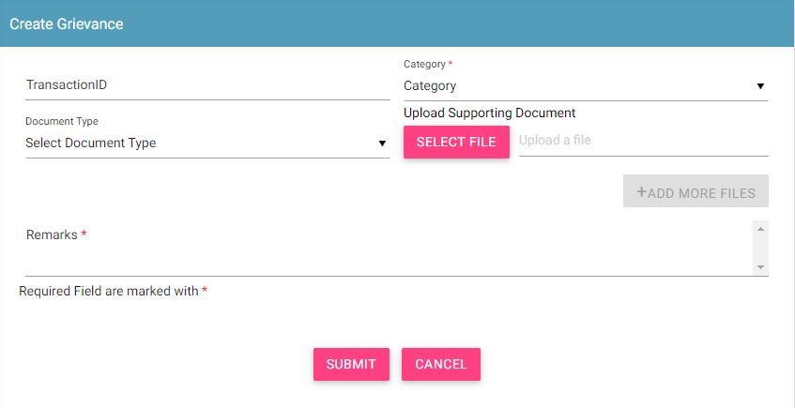

Figure 7a: Grievance – Create Grievance for internal users

1. Enter the following information for Internal user’s grievance form:
   1. **Transaction ID**: Enter the transaction ID of the type approval request if the grievance is related to a type approval request
   2. **\*Category**: Select the category of the grievance. The options are:

* Type Approval Related: Problem in reporting type approval request etc.
* Other: Problem with any other aspect of the application
* Registration Related: Problem with registering information in the application.
* Consignment Related: Problem related to consignment request
* Stock Management Related: Problem related to stock management request
  1. **\*Remarks:** Enter information about the grievance raised. This helps the administrator to understand the problem in detail.
  2. **Document Type:** Select the type of identification or another document that is to be uploaded. The options are:
* Passport
* Visa
* NID (National ID)
* Photo
* Other
  1. **Upload Supporting Document:** Click **Select File** to upload the document selected in **Document Type**.
  2. To upload more documents,click **+Add More Files.**

This adds two more fields: **Document Type** and **Upload Supporting Document**.

1. Click **SUBMIT**.
2. A grievance ID is generated and assigned to the registered grievance. A mail is sent to the use on whom behalf grievance has been raised.

OR

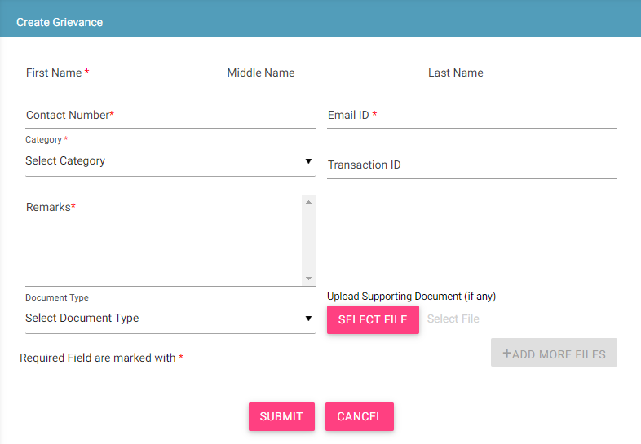

Figure 7b: Grievance – Create Grievance for external users

1. Enter the following information for External Users Grievance form:
   1. **\*First Name:** First name of end user
   2. **Middle Name:** Middle Name
   3. **Last Name:** Last Name
   4. **\*Contact Number:** Mobile Number
   5. **\*Email ID:** Email ID
   6. **Transaction ID**: Enter the transaction ID of the consignment if the grievance is related to a consignment or the transaction ID of the stock if the grievance is related to stock.
   7. **\*Category**: Select the category of the grievance. The options are:

* Consignment Related: Problem with registering consignment etc.
* Register Device Related: Problem with register device feature
* Stock Related: Problem with uploading stock etc.
* Other: Problem with any other aspect of the application
* Registration Related: Problem with registering information in the application.
  1. **\*Remarks:** Enter information about the grievance raised. This helps the administrator to understand the problem in detail.
  2. **Document Type:** Select the type of identification or another document that is to be uploaded. The options are:
* Passport
* Visa
* NID (National ID)
* Photo
* Other
  1. **Upload Supporting Document:** Click **Select File** to upload the document selected in **Document Type**.
  2. To upload more documents,click **+Add More Files.**

This adds two more fields: **Document Type** and **Select File**.

1. Click **SUBMIT**.

A grievance ID is generated and assigned to the registered grievance. A mail is sent to the use on whom behalf grievance has been raised.

## Filter Grievance

Customer Care Agents can view selective information by defining specific values in the listed fields. For example, Customer Care Agents can view the specific request during specified date by selecting start/end date.

To view specific request:

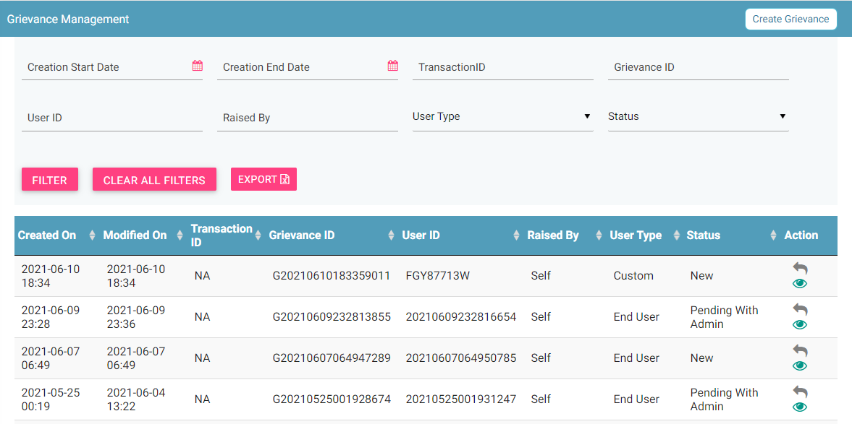

Figure 8: Grievance – Filter Option

1. Enter the required value in one or more of the listed fields:

* **Start Date:** Select the start date
* **End Date:** Select the end date
* **Transaction ID:** Enter the Transaction ID
* **Grievance ID:** Enter the Grievance ID
* **User ID:** Enter the user ID
* **Raised by:** Enter raised by which user
* **User Type:** Select the type of user
* **Grievance Status:** Select the status of grievance.

1. Click **FILTER**.

The parameter that matches the specified values is shown in the dashboard.

The user can clear all filters using the “**Clear All Filters**” button. This will reset all the filter values applied on the page and the data table will be refreshed.

## Sorting Grievances

By default, all records displayed are sorted based on modified date. User can sort the records by clicking the arrow button on header in the table displayed.

On first click, the records are sorted in ascending order. When user clicks the arrow buttons again, records are sorted in descending order.

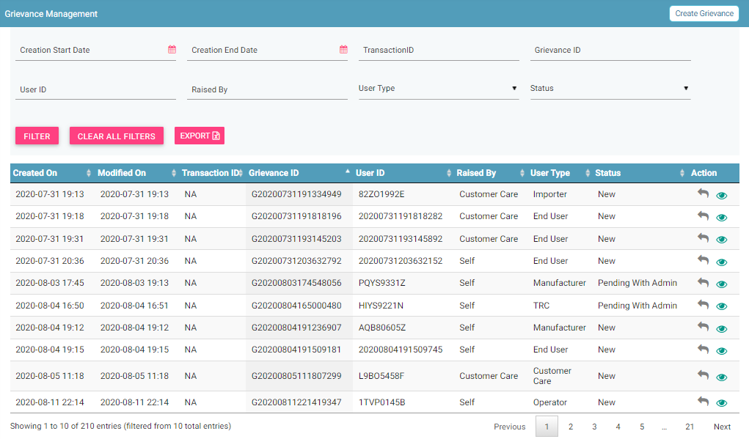

Figure 9: Sort Grievances

## Exporting Grievances

All the uploaded grievances can be downloaded in a **.csv** file. This is done using an export utility.

To export the grievances:

1. Click **Export** (seen on the top right corner of the **Grievance Management** page). 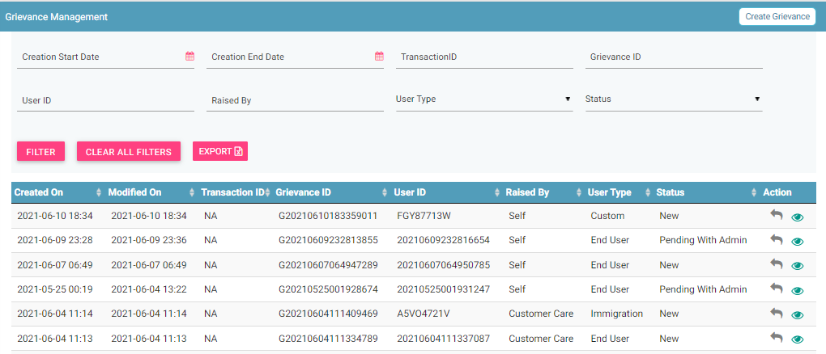

Figure 10: Grievance Management

The following page appears.

Figure 11: Open or Save Exported Grievance File

1. Click **Open with** to view the file.

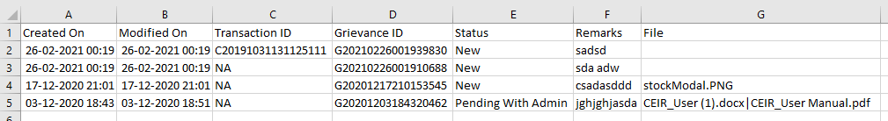

Figure 12: Exported Grievances

Instead of exporting all the grievances, personnel can export filtered grievances. First, filter the grievance data based on specific filters (refer to *Filter Grievances*) and then export the filtered grievances using the export utility.

## Search

Customer Care Agents can search the IMEI from the CEIR system using this feature

To search the IMEI:

1. Select **Search** in the left panel

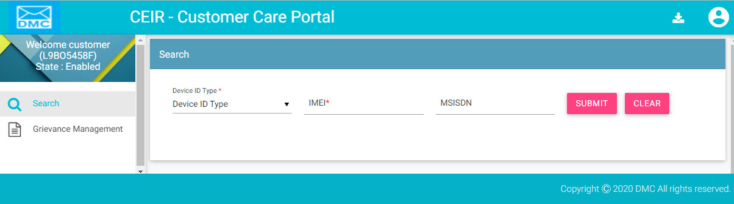

Figure 13: Search – IMEI

The following columns are seen in the Search Page

| **Column** | **Description** |
| --- | --- |
| Device ID Type | Select IMEI |
| IMEI | IMEI that the Customer Care Agent want to search |
| MSISDN | MSISDN that Customer Care Agent want to search |

Once the Customer Care Agent press the submit button, the Device Information page appears

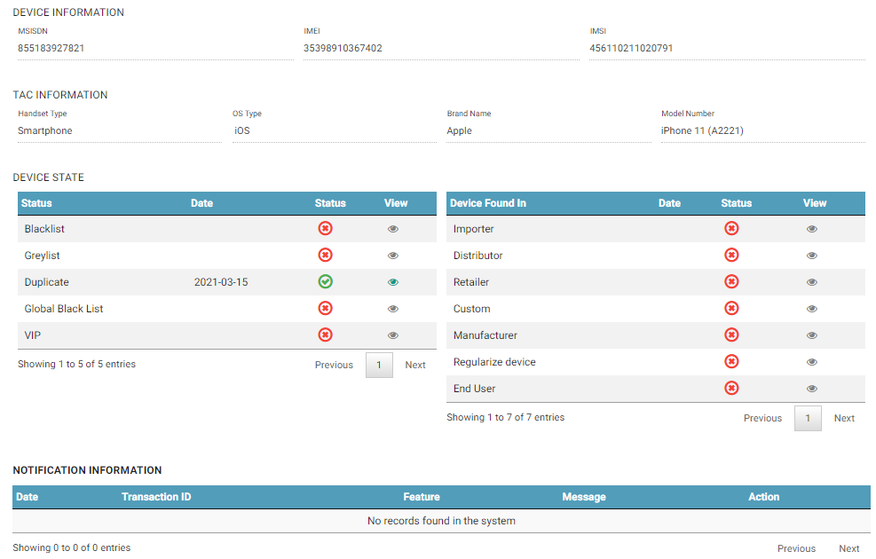

Figure 14: Search – Search IMEI

The page has the following information categorized into 4 heads

1) Device Information based on the IMEI usage in the network

| **Column** | **Description** |
| --- | --- |
| MSISDN | MSISDN would be displayed if any IMEI is in use with this MSISDN. |
| IMEI | IMEI that the Customer Care Agent searched |
| IMSI | IMSI would be displayed if any IMEI is in use with this IMSI |

2) TAC information based on the information as available if IMEI has a valid TAC

| **Column** | **Description** |
| --- | --- |
| Handset Type | If the IMEI has a valid TAC, then the Handset Type would be displayed |
| OS Type | If the IMEI has a valid TAC, then the OS Type would be displayed |
| Brand Name | If the IMEI has a valid TAC, then the Brand Name would be displayed |
| Model Number | If the IMEI has a valid TAC, then the Model Number would be displayed |

1. Device State
   1. Device Status in various conditions

| **Column** | **Description** |
| --- | --- |
| Status | If the device is present in Blacklist, Grey List, Duplicate List, Global Black List, or VIP List, an entry for the same will be displayed here. |
| Date | Date on which the entry is created in this list. It will be only be present if the IMEI exist in that list |
| Status | Indicate if the IMEI exist in list. |
| View | If the entry exists in list, the further details about this IMEI can be found for that list |

* 1. Device found in various lists as part of requests raised by users.

| **Column** | **Description** |
| --- | --- |
| Status | This contain if the IMEI is uploaded as part of request raised by Importer, Distributor, Retailer, Custom, Manufacturer, Regularize device, or an End user. End user denote the anonymous stock list uploaded by user. |
| Date | Date on which the entry is created in this list. It will be only be present if the IMEI exist in that list |
| Status | Indicate if the IMEI exist in list. |
| View | If the entry exists in list, the further details about this IMEI can be found for that list |

1. Notifications – In case the user IMEI is not found to be ok, then SMS notification is sent to the user

| **Column** | **Description** |
| --- | --- |
| Date | Date on which the notification is sent |
| Transaction ID | This field is not in use |
| Feature | Feature due to which this notification is sent. |
| Message | If the entry exists in list, the further details about this IMEI can be found for that list |
| Action | This is disabled. |